11.92: a) Taking torques about the pivot, the tensionin the cable is related to the weight by 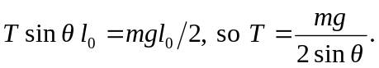 The horizontal component of the force that the cable exerts on the rod, and hence the horizontal component of the force that the pivot exerts on the rod, is 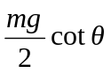and the stress is 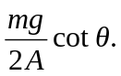 b)
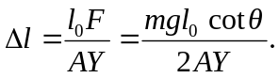
c) In terms of the density and length, 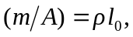 so the stress is 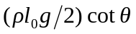 and the change in length is 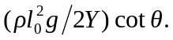 d) Using the numerical values, the stress is 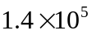 Pa and the change in length is 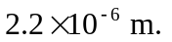e) The stress is proportional to the length and the change in length is proportional to the square of the length, and so the quantities change by factors of 2 and 4.

